NO IHA error que process

This is to process the no iha errors of the

First download the error que from the ActiveMQ server

1. ssh 10.228.145.117
2. sudo su
3. cd /mnt/apache-activemq-5.14.0/bin

we need to pull the error que we want to process into the active mq server

1. login into below server and copy the error que name as highlighted in screenshot

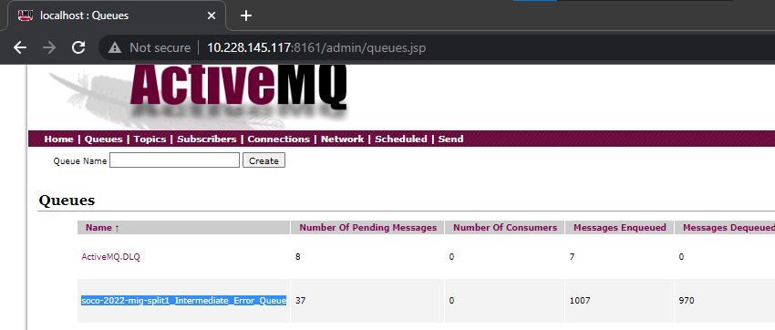

1. ./activemq browse --amqurl tcp://localhost:61616 soco-2022-mig-split1_Intermediate_Error_Queue > soco-2022-mig-split2_Intermediate_Error_Queue.txt
2. aws s3 cp soco-2022-mig-split2_Intermediate_Error_Queue.txt s3://ge-engineering/vamsheetest/queues/
3. from above path in s3 download to local and open into notepad++
4. 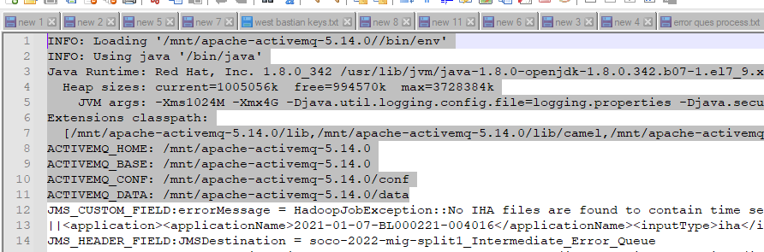
5. Remove the highlighted part in the file these line will be at the starting part of the file only
6. Goto Edit tab 🡪 select line operations 🡪 remove empty lines this will remove all the empty lines in the the file
7. No use replace option in CTRL+F function and need to replace some items to get the data in proper way
8. Type as give below and click on Replace All
9. 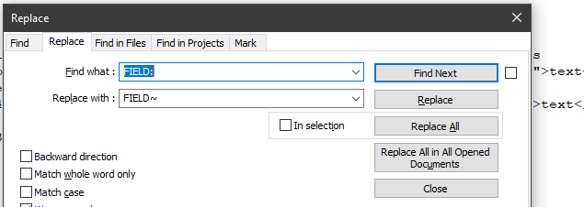
10. Here check the below options also and do the same this is remove space between lines and attach single error detail to single line

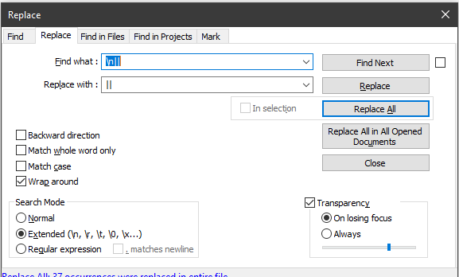

1. And copy the data to excel sheet
2. Here we must separate the data using delimiter in data tab and we get the dates of No-iha
3. Click on column A 🡪 goto data tab select “text to columns” menu ,

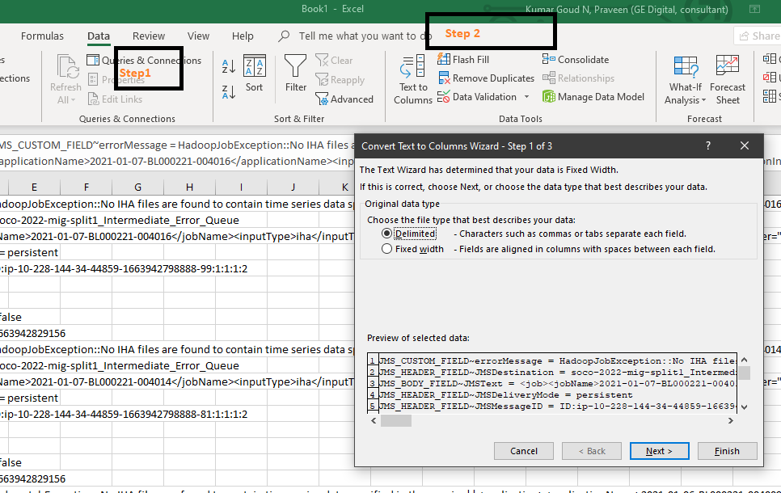

1. Click on next and keep as highlighted

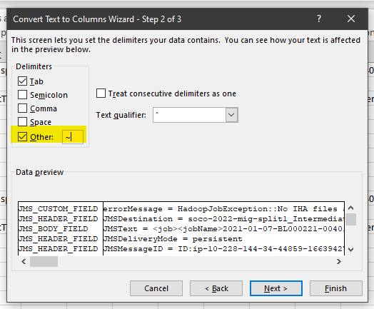

1. This operation will make data into 2 cloumns A & B , now apply filter and on column B filter search for “no iha”
2. Use delimted and apply “ > “ this will seprate many columns and we get dates into column copy that column and paste it into new sheet as Values .
3. If we paste them directly there will be gaps in rows to remove it we need to use paste values option after right click menu comes
4. Use delimted and apply “ - “ this will seprate many columns delete the last row , now we will be having
5. 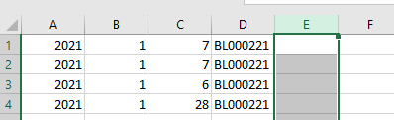
6. In column E use date formule “ DATE=(A1,B1,C1) and apply to all rows till where the data is there
7. Copy E column , use paste values option after right click menu comes beside it . and delete the E column
8. 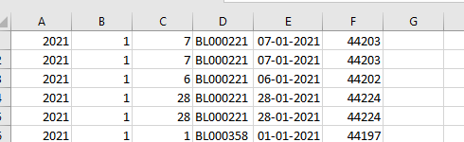
9. Delete the column E , now column F will come to E and select E and right click goto Format cells 🡪 custom 🡪 type this “yyyy-mm-dd”
10. And delete column A B C , and we get the assets and dates missing of that split . save those details into a seprate workbook naming the sheet with there Split names